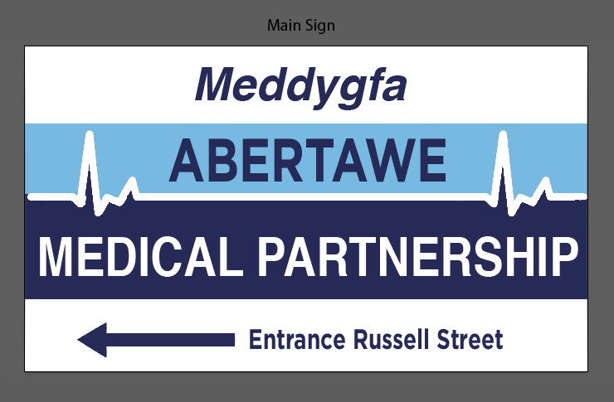**Data Sharing Opt-out only**.

The submission of the following form will enable the information held by us, Abertawe Medical Partnership, to stay private. This will mean that no medical or personal information will be shared with any third party without your expressed consent.

Full Name:________________________________________________

Date of Birth:______________________________________________

Address:__________________________________________________

_________________________________________________________

_________________________________________________________

_________________________________________________________

I would like to opt-out of the Data Sharing scheme

Date:_______________________________

Signed:______________________________